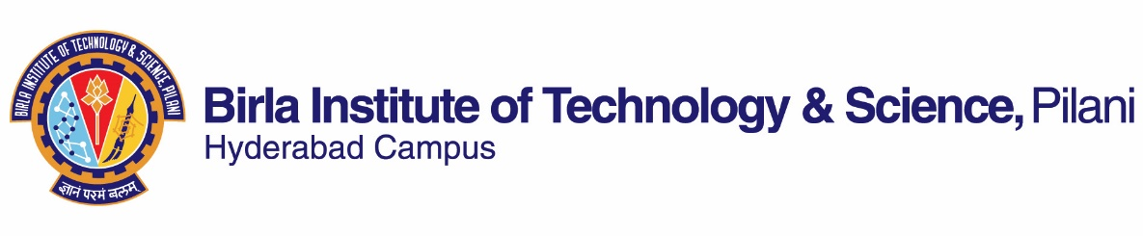

SECOND SEMESTER: 2018-2019
Course Handout (Part-II)
07-01-2019
In addition to Part I (General Handout for all courses appended to the time table) this portion gives further specific details regarding the course).
Course No. : BIO F244
Course Title : Instrumental Methods of Analysis
Instructor-in-charge : TRINATH JAMMA
Team of Instructors : Prof. Suman Kapur, Prof. Ramakrishna Vadrevu, Dr. Trinath Jamma, Naresh Patnaik, Pranay Amruth Maroju, Rolly Kumari
1. Scope & Objective of the Course:
The advent of dedicated bio-instruments and computers has facilitated an explosive progress in the instrumental methods of analysis in biology. Large number of data points, whether they are physicochemical or biological, can be collected, stored, manipulated and analyzed at a high precision with the help of modern sophisticated instruments having high sensitivity, selectivity, and extremely low detection limit. This course aims at providing a sufficient background of these instruments, their handling and application, in the field of molecular biology, structural biology and biotechnology.
2. Text Book:
T1. “Instrumental Methods of Analysis”, Sivasankar et. al., Oxford University Press, New Delhi, 1st ed., 2012.
T2. Lab Manual for PHA C391 IMA. Mahesh et. al,. 2008
Reference Book
R1. “Principles of Instrumental Analysis”, Skoog et. al., Harcourt Asia, 5th ed., 2001.
R2 “Instrument Methods of Analysis. Williard et al., CBS Publication, New Delhi, 7th edition, 1998.
R3 “Handbook of Analytical instruments”, R.S. Khandpur, Tata Mc Graw-Hill, 2nd edition, 2006.
3.a) Course Plan :
No | Learning Objectives | Topic to be covered | Ref. to the Book
1 | Spectroscopy | Characteristic of atomic and molecular spectroscopy | T-1 (Ch. 6)  R-1
2 | Atomic Spectroscopy | Infrared Spectroscopy  Atomic Absorption Spectroscopy, Flame Emission Spectroscopy | T-1 (Ch. 7)  R-1, R-3
3 | Molecular Spectroscopy | Visible and Ultraviolet Spectroscopy, Fluorescence Spectroscopy | T-1 (Ch. 8)  R-1, R-3
4 | Optical Spectroscopy | Polarimetry and Circular Dichroism | T-1 (Ch. 4)
5 | Electrophoresis | SDS-PAGE | T-1 (Ch. 14)  R-1
6 | Chromatography | High-Performance liquid Chromatography | T-1 (Ch. 13)  R-1, R-3
7 | Molecular Biology Techniques | ELISA, PCR | Class notes
8 | Mass Spectrometry | Basic principles and applications | T-1 (Ch. 10)

3. b) Lab Components:
Experiments
Exp 1: Preparation of buffer solutions and measurement of pH using a pH meter
Exp 2: Flame photometric analysis of alkaline earth metals in biological samples
Exp 3: Qualitative and quantitative analysis of biomolecules using UV spectroscopy
Exp 4: Fluorescent spectroscopy; total intensity and quenching measurements
Exp 5: Infrared spectroscopy; identification of functional groups in bio molecules
Exp 6: Separation of proteins using SDS-polyacrylamide gel electrophoresis
Exp 7: Identification of amino acids using TLC
Exp 8: Separation of molecules using HPLC
Exp 9: Measurement of molecular weight by mass spectrometry
Exp 10: Amplification of DNA using PCR
Exp 11: Atomic absorption spectrophotometric analysis of elements
Exp 12: Detection of antigen using an ELISA reader
Exp 13: Polarimeteric/ Circular Dichroic analysis of samples possessing optical activity
Note:
- Text book 2 will be used for experimental details
- Extra reading material will be provided to the students, if required.
- Minor changes are possible subject to availability of chemicals/ Instructors/Instruments
4. Evaluation Scheme:
No | Evaluation Component | Duration | Weightage | Date & Time | Nature of Component
1. | Laboratory Evaluation-1:  Evaluation will be based on Ist cycle experiments, punctuality, records, and participation. | - | 15% |  | OB
2. | Lab Quiz-1 | - | 10% |  | CB
3. | Midsem | 1 hr | 15% | 15/3  1.30 -3.00 PM | CB
4. | Laboratory Evaluation-2:  Evaluation will be based on 2nd cycle experiments, attendance, records, participation and viva. | - | 15% |  | OB
5. | Lab Quiz-2 | - | 10% |  | CB
6. | Lab comprehensive examination | - | 20% |  | OB
7. | Comprehensive Exam | 2 hr | 15% | 11/05 FN | CB
5. Guide to Writing Lab Reports:
The report must have to be written on hardbound, practical files. It should include the followings:
a. Objective of the experiments,
b. Theory on which the experiment is based,
c. Steps in the experimental procedure,
d. Results including all observations, e. Discussion and Conclusion. f. Precautions
6. Chamber Consultation Hours: To be announced in the Class.
7. Make-up Policy: Make-up will be granted only in the case of hospitalization and after submission of medical certificate through the proper process. No makeup for Laboratory evaluation.
8. Academic Honesty and Integrity Policy: Academic honesty and integrity are to be maintained by all the students throughout the semester and no type of academic dishonesty is acceptable.

IMPORTANT NOTE:
- Lab Coat is mandatory for performing experiments.
- You will not be allowed to do the experiments without your lab record.
- You must enter into lab on time; in case of delay, you may lose your evaluation and marks.

Instructor-in-charge
BIO-F244

